
STARS
School Transition & Adjustment Research Study

A study about moving to secondary school

QUESTIONNAIRE FOR YOUNG PEOPLE

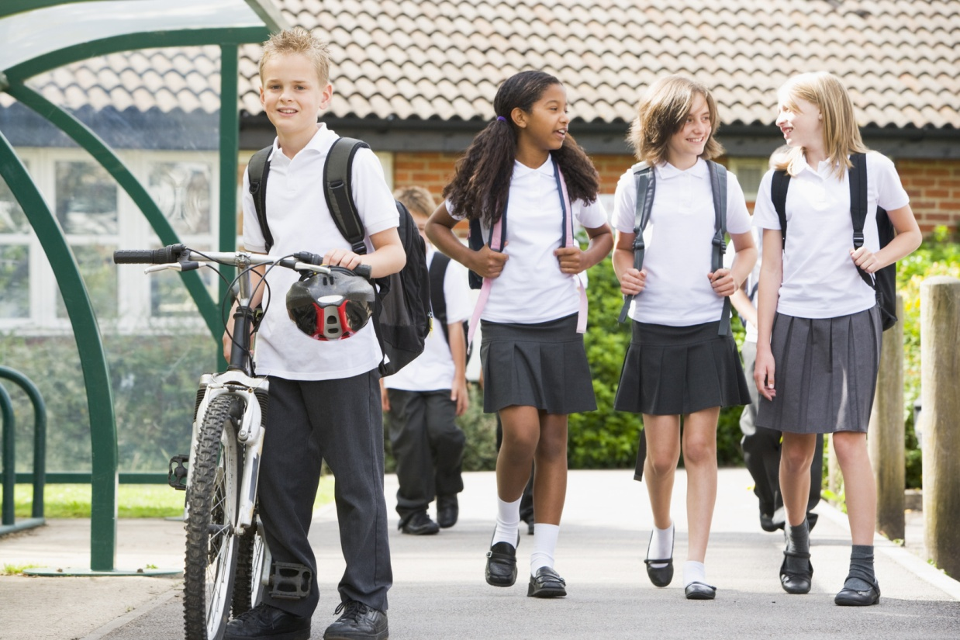

An online version of the questionnaire can also be completed instead at:
www.ucl.ac.uk/stars

Version for boys
ID number…………………………….(for office use)

INSTRUCTIONS FOR COMPLETING THIS QUESTIONNAIRE

This questionnaire contains a few different sections. It will ask you about your primary school, your life, friends and family, your feelings and behaviours and your move to secondary school. If there are any questions which you don’t want to answer, you can leave them out and move on to the next question.

Please make sure that:

- You have read (or have been read) the Information Sheet for Children and Young People provided. This tells you what you need to know about the study we are doing.
- You understand that your answers are completely confidential (private). This means that we won’t tell anyone what you write in this questionnaire. We make sure your information is kept private by not storing your name with your questionnaire.
- You understand what this project is about.
- You understand that it's OK to stop taking part at any time.
- You are happy to take part.

If you would like to take part……
please write your name, today’s date and sign

Your name | Date | Signature

If you don’t want to take part you should tick the box at the bottom of the sheet and return this page of the questionnaire to us in the freepost envelope provided.

I do not wish to take part this time
ID number…………………………….(for office use)

To complete the questionnaire:

- Make sure you read each question carefully before you answer.
- Answer the question by writing in an answer or ticking the right box,
for example:
1 | 2 | 3 | 4 | 5
- Mark only one answer for each question.
- Please try to answer every question.
- Once you have completed the questionnaire, please send it back to us in the envelope provided.

Everyone who responds will have the chance to win a shopping voucher worth £10.

Thank you for taking the time to be part of this study

How many years old are you? (please tick) | 9 | 10 | 11 |  | 12 | 13
Are you a boy or a girl? (please tick) | Boy |  |  | Girl

Your New Secondary School
Here is an example of a rating scale:

1 2 3 4 5 6 7 8 9 10
Not at all worried
I get extremely worried about it

We would like to ask you some questions about any concerns or worries you may have about your new secondary school. Please rate each of the following using the scale above.
For example, if you were really worried you would put a 10 in the box beside it.
Making new friends |  | Older children |  |  |  | Lots of different teachers |  |  |  |  | Following a timetable
Being bullied |  | Getting to school |  |  |  | Homework |  |  |  |  | Dinner times
PE |  | Changing classes |  |  |  | Being able to do the work |  |  |  |  | Toilets
Remembering equipment for school |  | What to do if you are feeling ill |  |  |  | Lots of people |  |  |  |  | Break time
Size of school |  | Discipline and detentions |  |  |  | Losing old friends |  |  |  |  | Getting lost
If you have any other concerns you can write in the boxes below and then rate your concerns with the same scale as above…
................................................................................ |  |  |  |  |  | ................................................................................
Please tick your answer to the following questions: |  |  |  |  |  |  | Not at all |  | Very little |  |  | Somewhat |  | Quite a bit | Very much
- Are you looking forward to going to secondary school? |  |  |  |  |  |  | 1 |  | 2 |  |  | 3 |  | 4 | 5
- Are you worried about going to secondary school? |  |  |  |  |  |  | 1 |  | 2 |  |  | 3 |  | 4 | 5
- Do you feel prepared for going to secondary school? |  |  |  |  |  |  | 1 |  | 2 |  |  | 3 |  | 4 | 5
- Is there anything that you don’t feel prepared for? |  |  |  |  |  |  | 1 |  | 2 |  |  | 3 |  | 4 | 5
If yes, what is it?
........................................................................................................................................
- Which secondary school will you be going to?
…………………………………………………………………………….
- Did you want to go to this school? |  |  |  |  |  |  | Yes |  |  |  |  |  | No
- Did you go to your new school’s open day/evening before making up your mind? |  |  |  |  |  |  | Yes |  |  |  |  |  | No
- Has your Year 6 teacher talked to you about any of these things about secondary school? Please tick.
Having more than one teacher in Year 7 |  |  |  | Changing classrooms between lessons |  |  |  | Lunch system
Behaviour and discipline |  |  |  | Having new subjects |  |  |  | Not being with same pupils in all lessons
Other (please write here)
……………...............................................................................................................
- Have any of your new teachers visited your year 6 class? |  |  |  |  |  |  | Yes |  |  |  |  |  | No

Your Life

Below is a list of things that sometimes happen to children and young people. We would like you to think about the past year, that is the last 12 months. Did this happen in the last 12 months? If yes, please tick.
- Moving to a new neighbourhood |  | - Joining a new club
- Birth of a new brother, sister or adopted or fostered child |  | - Doing badly in an exam
- A new stepbrother or stepsister |  | - Parent being less interested or loving towards you
- Serious illness or injury in a parent, brother or sister |  | - Parent nagging or picking on you more
- Parents divorced or separated |  | - Serious illness to you
- Increased quarrelling between parents |  | - Failing to be picked for a school or club team, band or orchestra
- Death of parent, brother or sister |  | - Doing badly in school work
- Death of grandparent |  | - Being picked for a school or club team, band or orchestra
- Death of a close friend |  | - Special prize or recognition for doing well in an activity (like sports, music or art)
- Father/stepfather away from home more often |  | - A close friend moves a long way away
- Mother/stepmother away from home more often |  | - Losing a close friend through arguments or being dropped
Please tick.
- Brother or sister (or step-brother/step sister) leaving home |  | - Death of a pet
- Serious illness or injury in a close friend |  | - Mother losing job
- Parent getting into trouble with the police |  | - Father losing job
- Mother or stepmother going back to work or starting work for the first time |  | - Serious injury to you
- Entry into the home of a new partner for mother or father |  | - Being bullied
- Parent going to prison |  | - Special recognition for good school work
If there is anything else you think might be important, please write it here
……………………………………………………………………………….……………………………………………………………………………………
Now about your friends and family…

Your Family
Not all families are the same, so some of the next questions might not apply to you.
A | During the past month when you and your mum (or the person like your mum, e.g. carer, step-mum) have spent time talking or doing things together, how often did your mum...
If you have not been in touch with them in the last month please tick here and go on to ‘B’.
 |  |  | Always | Almost Always | Fairly Often | About Half | Not too Often | Almost Never | Never
- Get angry at you |  |  | 1 | 2 | 3 | 4 | 5 | 6 | 7
- Let you know she really cares about you |  |  | 1 | 2 | 3 | 4 | 5 | 6 | 7
- Criticise you or your ideas |  |  | 1 | 2 | 3 | 4 | 5 | 6 | 7
- Shout at you because she was upset with you |  |  | 1 | 2 | 3 | 4 | 5 | 6 | 7
- Act loving and affectionate toward you |  |  | 1 | 2 | 3 | 4 | 5 | 6 | 7
- Let you know that she appreciates you, your ideas or the things you do |  |  | 1 | 2 | 3 | 4 | 5 | 6 | 7
- Help you do something that was important to you |  |  | 1 | 2 | 3 | 4 | 5 | 6 | 7
- Argue with you when you disagreed about something |  |  | 1 | 2 | 3 | 4 | 5 | 6 | 7
- Act supportive and understanding toward you |  |  | 1 | 2 | 3 | 4 | 5 | 6 | 7
- Tell you she loves you |  |  | 1 | 2 | 3 | 4 | 5 | 6 | 7
B |  | During the past month when you and your dad (or the person like your dad, e.g. carer, step-dad) have spent time talking or doing things together, how often did your dad...
If you have not been in touch with them in the last month please tick here and go on to ‘C’.
 |  |  | Always | Almost Always | Fairly Often | About Half | Not too Often | Almost Never | Never
- Get angry at you |  |  | 1 | 2 | 3 | 4 | 5 | 6 | 7
- Let you know he really cares about you |  |  | 1 | 2 | 3 | 4 | 5 | 6 | 7
- Criticise you or your ideas |  |  | 1 | 2 | 3 | 4 | 5 | 6 | 7
- Shout at you because he was upset with you |  |  | 1 | 2 | 3 | 4 | 5 | 6 | 7
- Act loving and affectionate toward you |  |  | 1 | 2 | 3 | 4 | 5 | 6 | 7
- Let you know that he appreciates you, your ideas or the things you do |  |  | 1 | 2 | 3 | 4 | 5 | 6 | 7
- Help you do something that was important to you |  |  | 1 | 2 | 3 | 4 | 5 | 6 | 7
- Argue with you when you disagreed about something |  |  | 1 | 2 | 3 | 4 | 5 | 6 | 7
- Act supportive and understanding toward you |  |  | 1 | 2 | 3 | 4 | 5 | 6 | 7
- Tell you he loves you |  |  | 1 | 2 | 3 | 4 | 5 | 6 | 7

Your Behaviour
For each item, please tick the box for Not True, Sort of True or Certainly True. It would help us if you answered all items as best you can, even if you are not absolutely certain. Please give your answers on the basis of your behaviour over the last 6 months.
 | Not True |  |  | Sort of True |  |  | Certainly True
- I try to be nice to other people, I care about their feelings | 0 |  |  | 1 |  |  | 2
- I am restless, I cannot stay still for long | 0 |  |  | 1 |  |  | 2
- I get a lot of headaches, stomach-aches or sickness | 0 |  |  | 1 |  |  | 2
- I usually share with others (food, games, pens, etc.) | 0 |  |  | 1 |  |  | 2
- I get very angry and often lose my temper | 0 |  |  | 1 |  |  | 2
- I am usually on my own. I generally play alone or keep to myself | 0 |  |  | 1 |  |  | 2
- I usually do as I am told | 0 |  |  | 1 |  |  | 2
- I worry a lot | 0 |  |  | 1 |  |  | 2
- I am helpful if someone is hurt, upset or feeling ill | 0 |  |  | 1 |  |  | 2
- I am constantly fidgeting or squirming | 0 |  |  | 1 |  |  | 2
- I have one good friend or more | 0 |  |  | 1 |  |  | 2
- I fight a lot. I can make other people do what I want | 0 |  |  | 1 |  |  | 2
- I am often unhappy, down-hearted or tearful | 0 |  |  | 1 |  |  | 2
- Other people my age generally like me | 0 |  |  | 1 |  |  | 2
- I am easily distracted, I find it difficult to concentrate | 0 |  |  | 1 |  |  | 2
- I am nervous in new situations. I easily lose confidence | 0 |  |  | 1 |  |  | 2
- I am kind to younger children | 0 |  |  | 1 |  |  | 2
- I am often accused of lying or cheating | 0 |  |  | 1 |  |  | 2
- Other children or young people pick on me or bully me | 0 |  |  | 1 |  |  | 2
- I often volunteer to help others (parents, teachers, children) | 0 |  |  | 1 |  |  | 2
- I think before I do things | 0 |  |  | 1 |  |  | 2
- I take things that are not mine from home, school or elsewhere | 0 |  |  | 1 |  |  | 2
- I get on better with adults than with people my own age | 0 |  |  | 1 |  |  | 2
- I have many fears, I am easily scared | 0 |  |  | 1 |  |  | 2
- I finish the work I am doing. My attention is good | 0 |  |  | 1 |  |  | 2
How much does each of these sentences describe how you usually behave? |  | Not at all | Very little |  | Some-what | Quite a bit |  | Very much
- I am good at resisting temptation |  | 1 | 2 |  | 3 | 4 |  | 5
- I find it hard to break bad habits |  | 1 | 2 |  | 3 | 4 |  | 5
- I am lazy |  | 1 | 2 |  | 3 | 4 |  | 5
- I say inappropriate things |  | 1 | 2 |  | 3 | 4 |  | 5
- I do certain things that are bad for me, if they are fun |  | 1 | 2 |  | 3 | 4 |  | 5
- I refuse things that are bad for me |  | 1 | 2 |  | 3 | 4 |  | 5
- I wish I had more self-control |  | 1 | 2 |  | 3 | 4 |  | 5
- People would say that I have strong self-control |  | 1 | 2 |  | 3 | 4 |  | 5
- Enjoyment and fun sometimes keep me from getting work done |  | 1 | 2 |  | 3 | 4 |  | 5
- I have trouble concentrating |  | 1 | 2 |  | 3 | 4 |  | 5
- I can work well towards long-term goals |  | 1 | 2 |  | 3 | 4 |  | 5
- Sometimes I can’t stop myself from doing something, even if I know it is wrong |  | 1 | 2 |  | 3 | 4 |  | 5
- I often act without thinking through all my choices |  | 1 | 2 |  | 3 | 4 |  | 5

One more section to go…


Your School Now

Answer about the primary school that you are currently attending (while you are in year 6). | Strongly Disagree | Disagree | Not sure | Agree | Strongly Agree
- You feel close to people at school | 1 | 2 | 3 | 4 | 5
- Teachers care about you | 1 | 2 | 3 | 4 | 5
- You feel part of your school | 1 | 2 | 3 | 4 | 5
- You feel happy at school | 1 | 2 | 3 | 4 | 5
- You feel teachers treat students fairly | 1 | 2 | 3 | 4 | 5
- You feel safe in your school | 1 | 2 | 3 | 4 | 5
 | Not true at all | Hardly ever true | Some-times true | True most of the time | Always true
- It is easy for me to make new friends at school | 1 | 2 | 3 | 4 | 5
- I have nobody to talk to in class | 1 | 2 | 3 | 4 | 5
- I’m good at working with other children in my class | 1 | 2 | 3 | 4 | 5
- It’s hard for me to make friends at school | 1 | 2 | 3 | 4 | 5
- I have lots of friends in my class | 1 | 2 | 3 | 4 | 5
- I feel alone at school | 1 | 2 | 3 | 4 | 5
- I can find a friend in my class when I need one | 1 | 2 | 3 | 4 | 5
- It’s hard to get children at school to like me | 1 | 2 | 3 | 4 | 5
- I don’t have anyone to play with at school | 1 | 2 | 3 | 4 | 5
- I get along with my classmates | 1 | 2 | 3 | 4 | 5
- I feel left out of things at school | 1 | 2 | 3 | 4 | 5
- There’s no other children I can go to when I need help in school | 1 | 2 | 3 | 4 | 5
- I don’t get along with other children in school | 1 | 2 | 3 | 4 | 5
- I’m lonely at school | 1 | 2 | 3 | 4 | 5
- I am well liked by the children in my class | 1 | 2 | 3 | 4 | 5
- I don’t have any friends in class | 1 | 2 | 3 | 4 | 5

 | Never | Seldom |  | Some-times |  | Often |  | Always
- How often do you try to learn something new even when you don't have to? | 1 | 2 |  | 3 |  | 4 |  | 5
- How often do you try to learn as much as you can about a new subject? | 1 | 2 |  | 3 |  | 4 |  | 5
- How often do you try to work hard to understand what you are studying? | 1 | 2 |  | 3 |  | 4 |  | 5
- How often do you try to find things to learn in class that are new and challenging? | 1 | 2 |  | 3 |  | 4 |  | 5
- How often do you try to show your teachers how clever you are? | 1 | 2 |  | 3 |  | 4 |  | 5
- How often do you try to learn things ONLY because you want to get a good mark? | 1 | 2 |  | 3 |  | 4 |  | 5
- How often do you try to make sure your teachers know you have been working hard? | 1 | 2 |  | 3 |  | 4 |  | 5
- How often do you try to get better marks than other children in your class? | 1 | 2 |  | 3 |  | 4 |  | 5
- How often do you try to show you've learned more than your classmates? | 1 | 2 |  | 3 |  | 4 |  | 5
- How often do you try to get more answers right than your classmates? | 1 | 2 |  | 3 |  | 4 |  | 5
If the statement is definitely true, tick ‘1’ for ‘YES!!’. If you think the statement is definitely not true, tick ‘4’ for ‘NO!!’. | YES!! |  | yes |  | no |  | NO!!
- The teachers here really care about me | 1 |  | 2 |  | 3 |  | 4
- Teachers can’t be trusted; they say one thing at one time and something different the next time | 1 |  | 2 |  | 3 |  | 4
- The teachers here always keep their promises | 1 |  | 2 |  | 3 |  | 4
- The teachers here don’t care what I think | 1 |  | 2 |  | 3 |  | 4
- The teachers here always try to be fair | 1 |  | 2 |  | 3 |  | 4
- Teachers here punish children without even knowing what really happened | 1 |  | 2 |  | 3 |  | 4
- I feel safe and comfortable with the teachers in this school | 1 |  | 2 |  | 3 |  | 4
- Teachers in this school get cross whenever you make a mistake | 1 |  | 2 |  | 3 |  | 4
- When my teacher tells me not to do something I want to do, I know he or she must have a good reason | 1 |  | 2 |  | 3 |  | 4
- Our teacher will always listen to our ideas about how to make the class rules better | 1 |  | 2 |  | 3 |  | 4

Thank you for completing this questionnaire.



Please return in the pre-paid envelope provided or post to:

